Executive Overview
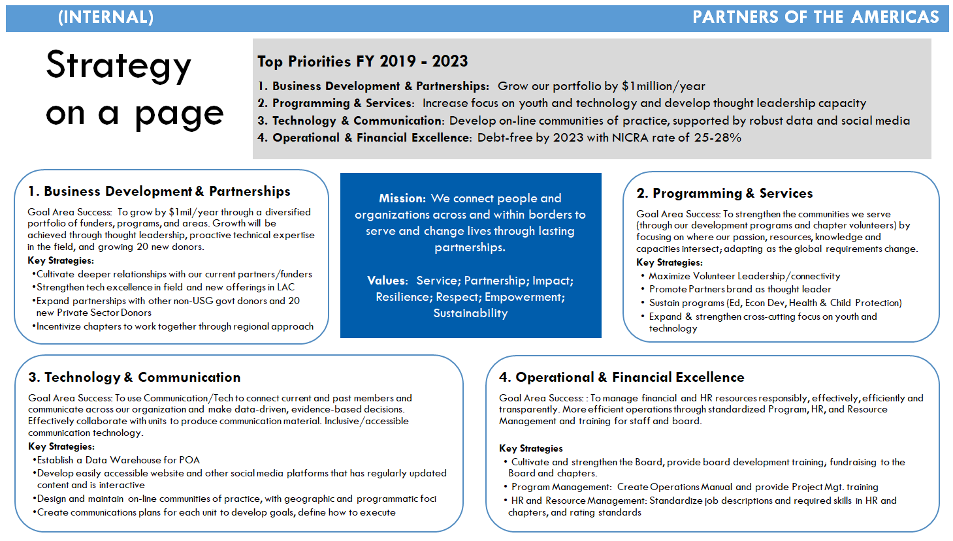

Goal Success Statement & Measures of Success

Success Statement
To manage financial and HR resources responsibly, effectively, efficiently and transparently. More efficient operations through standardized Program, HR, and Resource Management and training for staff and board.

Success Measures
- Resource revenue
- Reserves/debt free
- Institutional memory
- Solid organization chart
- Specific roles description.
- New operation standards.
- Board training, engagement, sufficient information for chapters.
- Organization live long life.
- M&E indicators, outputs, outcomes/impact.

Key strategies

Operational & Financial Excellence
- Strategy to develop the Board, provide training especially training of fundraising to the Board and chapters.
- Project management training.
- Standardize job descriptions and required skills in HR and chapters, and rating standards.

Rapid Prototyping
Brainstorm
Theme
Prototype

Programs Mgmt. Manual: Financial, Compliance, COMM, contractual, Admin protocols, Risk management.
- Budget consultation
- Program financial Manual
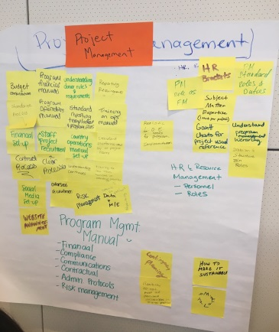
- Standardize processes/Program operations manual/Training on OPS manual
- Understanding donor rules and requirements
- Reporting requirements
- Standard reporting templates and program files
- Financial set-up
- Project staff recruitment
- Country operations manual set-up
- Standard platforms used by all project teams
- Contract process
- Understanding contracts
- Training for new team members on standard process
- Social media set-up
- Overseas recruitment
- Risk management
- Data and M&E

HR & Resource Management: Personnel, Roles.
- PM roles as FM
- HR brackets
- PM standard roles and duties
- Subject Matter expertise
- Division & structure B/n roles.

Partners Strategy Roadmap

